**Name:** Safyan Anwar

**Roll no:** BSSE-S24-018

**Section:** 3A-BSSE

**Assignment #:** 7

**Submitted to:** Sir. Rasikh

**LAB # 7:**

**Code:**

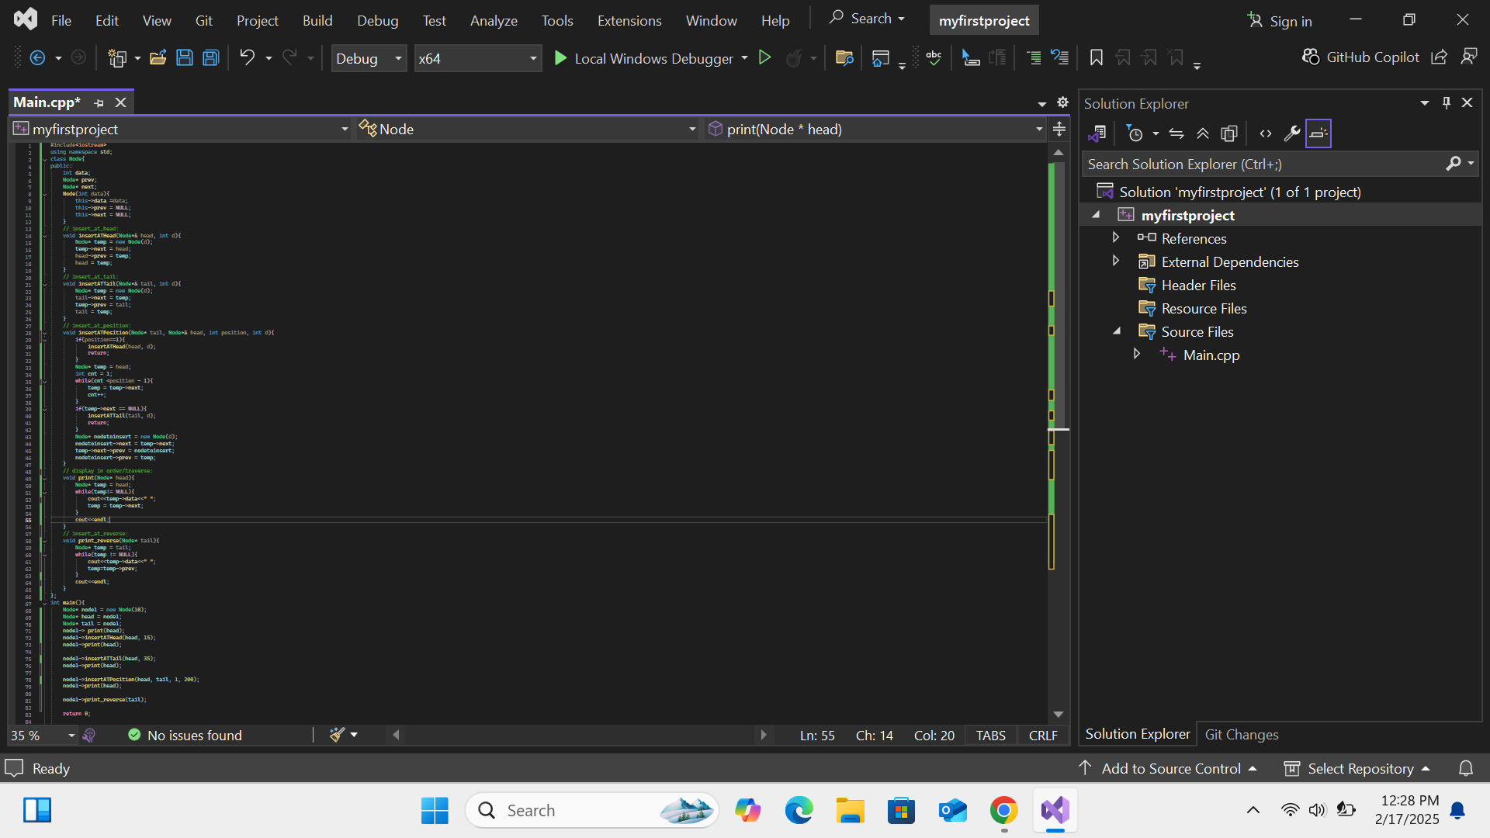

**Output:**

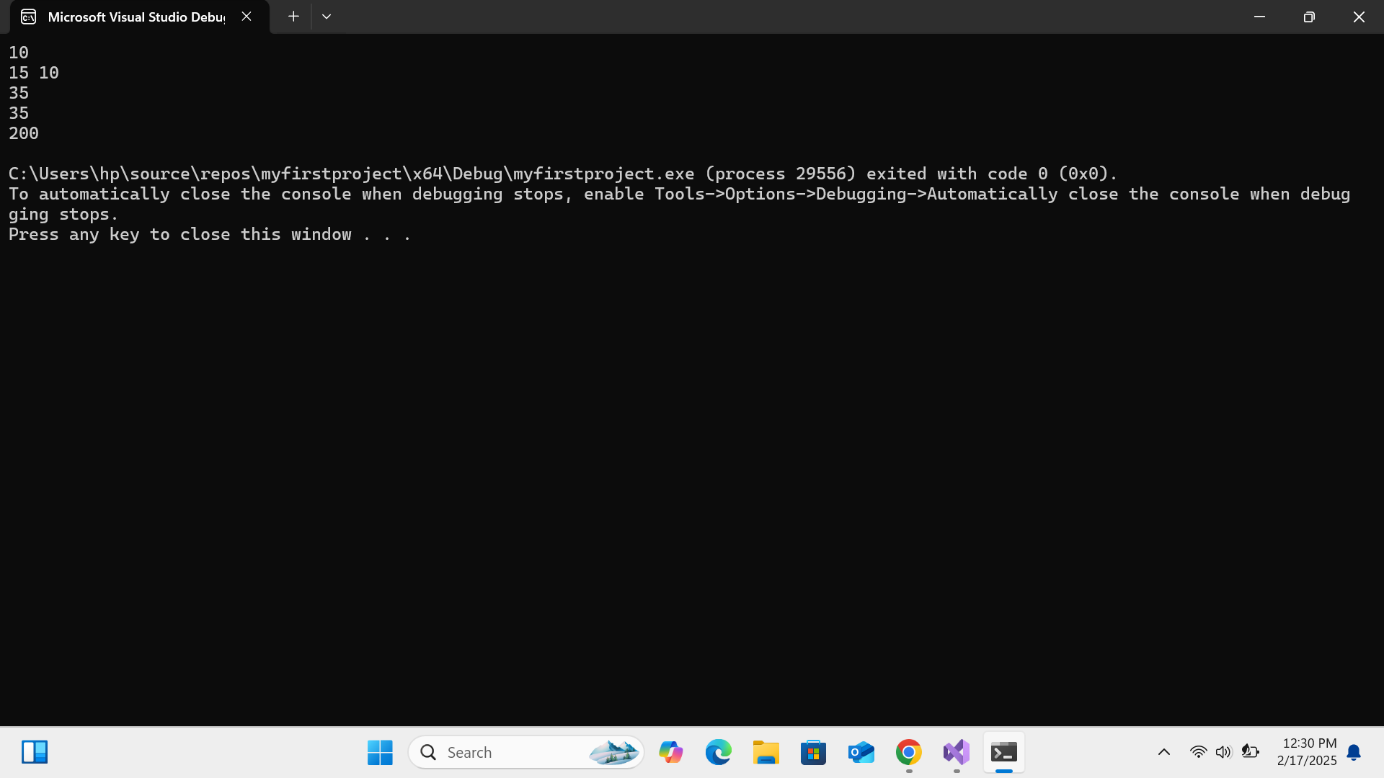

**Explanation:**

I first of all create a class ‘Node’ and i pass the attributes ‘data’ data hold the value of data and ‘prev’ the node before in the list ‘next’ a pointer that refer node after it in the list. ‘insertATHead’ it is make the new node point to the current head node and update the head to be a new node. ‘insertATTail’ its makes the current tail node point to the new node and the new node points back to the current tail. ‘insertATPosition’ the position is 1 the start it calls the insertATHead function and i set the position. And ‘print in order/traverse’ print the list from the start to the end. ‘Display in reverse’ print the list from the end to the start. And you show output.